Audit checkup

Vulnerabilities found:
  - Credentials:
When u close the app and reopen it should ask u to provide a password or a pin (because this is important medical information) but it does not. This is a serious security risk as it essentially allows access to the account and its records by anyone who has access to that device.
  - Make the application stable:
This application is very unstable and often crashes over small things mostly when going through tabs quickly and the slighting wheel.

  - Personal details
When you finished creating an account you can still visit the account page if you need to change details. The issue here, is if you try to leave it will ask you to complete the changes to the profile (even though you already entered them previously in the account creation).

  - Brute force attack
Brute force attack is going to a login screen and just keep entering the password repeatedly trying to guess it so that maybe eventually the attacker will get it right. Most hackers use a bot that quickly enters keyboard keystrokes in fast and quickly of all the passwords possible.
A fix to this would include:
- limiting the number of attempts available. (which could be enforced by detecting the users IP address and its password attempts).
- Using CAPTCHA or Cloudflare to prevent bots from attempting it
- Alerting the user who owns the account via email or text that someone is trying to enter the account.

  - Character length:
By entering to many texts at once can cause the server to crash. This can be fixed by having character text length limits in place

Recommendations for software:

  - Error codes.
When something isn’t working and the software detects this, it can provide the user with an error code. This error code can be used to search for in our data base. Error codes are great because instead of showing the user what exactly went wrong (which can be long and complicated) it provides them a code for them to write down and report to our team which they can then search and lookup and find why the error happened.

  - Feedback button:
This is great for us as it doesn’t just rely on only developers to report bugs or other issues but the consumer as well. they can report bugs or request features as well or anything else they desire to give feedback on.
This is good as it provides you an authentic view through the Lense of the consumer for their wants and needs.

OS specific bugs
I discovered many bugs in the software and have categoriesed them as IOS and Android in the next few pages a head.

IOS versions:

- Setup screen
The account creation menu has a bug. The adding date of birth menu slots are not visible (they are still there because when I scroll through it does select them). Then I was tapping the year to see if I could change it that way. I kept tapping that and the whole thing crashed. Video included below:
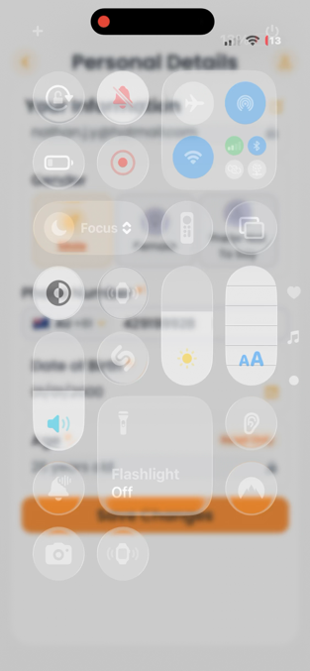

It’s not just in the sign-up menu but also everywhere else on the app that uses a scrolling wheel mechanic to select something.

- Skip button (only iPadOS devices)
Skip button does not work only on iPadOS (different to iOS which is devices for iPad) on setup screen. It doesn’t work in stage manager mode or windowed app mode (iPados feature that makes iPadOS behave like macOS). The skip button only starts working when you click the ‘begin your health journey’ button, then it works but does not on the first screen when opening the app. Screenshot below:

- Interface UI on iPadOS incorrect
Interface UI for iPadOS is not properly configured. Things are not where they are supposed to be because it is not able to detect that this is an iPad not an iPhone. These issues could also affect other phone devices that are bigger or smaller than normal. See video below to see what I am talking about:
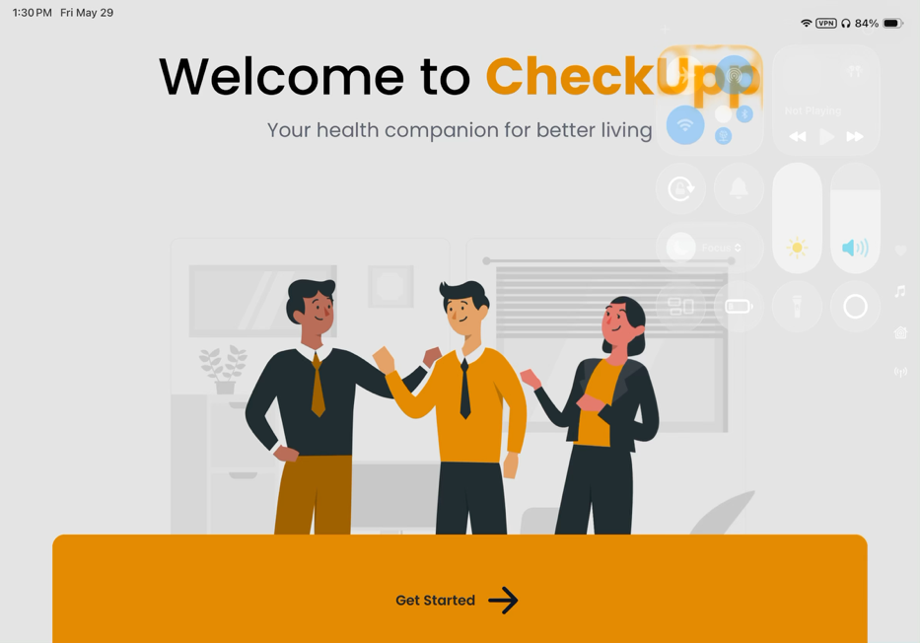

Android:

- Sign in issues.
This issue only happens sometimes when I login. I select my login and it will sometimes say it doesn’t work. I either close the app and re-open it or just keep spamming the login details and that also works. This bug is different to the last one (we talked about in the meeting before) as it works on my iPhone but only sometimes on the android device.
Here is a photo of what it looks like below:
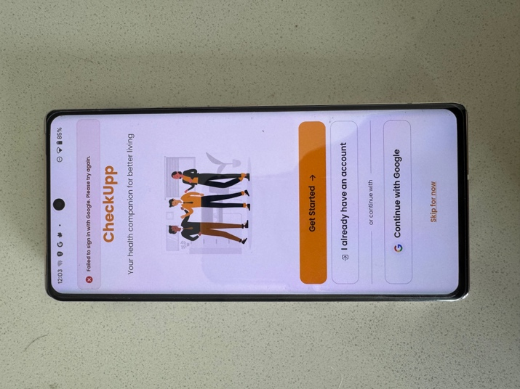

I recommend having an error code as well in this situation. See page 3 for more information about error codes.

